

Project Manual

Project: PLCopen-Editor

Course: Software Engineering

Class: Tinf19C

Professor: Christian Holder, Markus Rentschler

Project manager: Mouaz Tabboush

Team members: Elian Yildirim
Franziska Kopp
Leonie de Santis

Version: PHB 1.0, May 2021
Contents

1. Table of revision 3
2. Project assignment 4
3. Project Objectives Plan 5
4. Project context 6
5. Project organization 7
6. Work Breakdown Structure (WBS) 8
7. WP-Description 9
8. Milestone plan 10
9. Gantt chart 11
10. Project risks 12
11. List of Operations 13

Table of revision
Version | Date | Comment | Author
0.1 | 02.11.2020 | Created  Project assignment und Project organization | Leonie de Santis
0.2 | 03.11.2020 | Work breakdown structure | Mouaz Tabboush
0.3 | 03.11.2020 | Project context, Project Objectives Plan, WP-Description, Milestone plan, Gantt chart, Project risks | Leonie de Santis
0.4 | 13.05.2021 | Update List of Operations | Leonie de Santis
1.0 | 14.05.2021 | Update Gantt chart | Leonie de Santis

Project assignment
Project assignment
Project objective (Output):  Development of an editor GUI, which supports the PLC programming languages FBD (Function Block Diagram) and SFC (Sequential Function Chart). The common logic blocks should be available as graphical library elements and should be able to be dragged into the editor window and connected with each other.  It should be possible to save and load the PLC programs as PLCopen or AML. | Non-objectives / Non-contents:  - The PLC programming languages LAD, IL and ST need not be supported  - The verification of the function of an example program on a runtime system was taken from the requirements and is optional.  .
Project benefits (Outcome):
With the PLCopen-Editor GUI graphical PLC programs can be created. The languages FBD and SFC as well as the common logic blocks are available for this purpose. The programs can be saved or loaded as PLCopen XML or AML files.
The exported file can be imported and loaded in other development environments (e.g. AML editor).
Project client: C. Holder; M. Rentschler | Project manager: Mouaz Tabboush
Team members:  - Elian Yildirim  - Franziska Kopp  - Leonie de Santis | Other defendants:
Main tasks:  - Documentation  - Analysis  - Design  - Coding  - Testing | Milestones:  - Analysis- / Design-Phase  - Coding-Phase  - Testing-Phase  - Project completion
Start of project: Introductory lecture and project awarding | Start date: 11.09.2020
End of project: Presentation of the result | End date: Mai 2021

Project Objectives Plan
Objective type | Project objectives
Sub-objectives: | Design:  - Workflow  - Editor GUI  - Import/Export  Coding:  - Homepage  - Editor window  - Programming languages: FBD, SFC  - FBs that are dragged into the editor window and connected  - Import/Export  Testing:  - Error Detecting  - GUI Testing  - Export Testing  - Side effects (Delete, Move, …)  - Components (Function Blocks, Connectors, Variables)

Project context
Initial situation
For the creation of PLC programs there is an editor of the open source project OpenPLC, which can be used as a reference.

Temporal project context
Pre-project phase | Post-project phase
- Familiarization in PLC  - Familiarization with the OpenPLC editor | - Further PLC programming languages can be added  - Additional function modules can be added

Factual project context
Context | Measures required
Other projects and exams in the theoretical phase | Fair distribution of tasks within the team and keeping to deadlines
Projects in the practical phase and the resulting time constraints | Longer periods of time for tasks to be performed

Social context
Stakeholder group | Potentials / Chances | Conflicts / Risks | Measures
Client | Satisfied with the results | Changes in requirements during the project phase | Clear and regular communication between client and contractor
Contractor | Achieving the requirements | Difficulties within the team and time conflicts | Useful, regular meetings and keeping to deadlines
User | Using the PLCopen-Editor | difficulties in handling the program | Clear GUI structure and self-explanatory operation

Project organization
Project role | Role Description | Name
Project client | - Client | C. Holder  M. Rentschler
Project manager | - Project manager und Test manager | Mouaz Tabboush
Team members | - Developer  - Technical writer  - Product manager  - Test manager | Elian Yildirim  Franziska Kopp  Leonie de Santis

Project manager

Mouaz Tabboush
Team member

Elian Yildirim
Team member

Franziska Kopp
Project client

C.Holder/M. Rentschler
Team member

Leonie de Santis

Work Breakdown Structure (WBS)

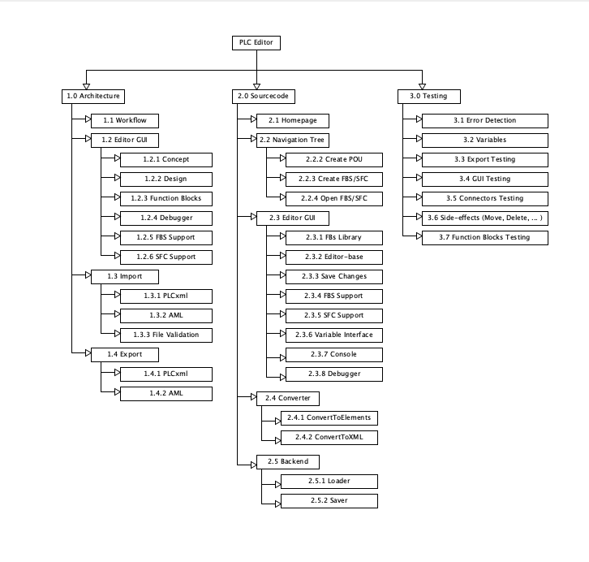

WP-Description
Work package: 0.0 Analysis
WP content / outcome: | - CRS  - SRS  - BC  - PM  - SAS
Ownership: | Mouaz Tabboush, Leonie de Santis
Collaboration: | Elian Yildirim, Franziska Kopp

Work package: 1.0 Architecture/Design
WP content / outcome: | - Workflow  - Editor GUI  - Import, Export
Ownership: | Elian Yildirim, Mouaz Tabboush
Collaboration: | Franziska Kopp, Leonie de Santis

Work package: 2.0 Coding
WP content / outcome: | - Homepage  - Project overview  - Editor  - FBD, SFC, FB  - Import. Export  - Converter
Ownership: | Leonie de Santis, Franziska Kopp
Collaboration: | Mouaz Tabboush, Elian Yildirim

Work package: 3.0 Testing
WP content / outcome: | - Error Detecting  - Variables  - Export: PLCopen XML / AML testing  - GUI testing  - Side-effects (Delete, Move, …)  - Function Blocks
Ownership: | Franziska Kopp, Elian Yildirim
Collaboration: | Leonie de Santis, Mouaz Tabboush

Milestone plan
PSP-Code | Milestone name | PLAN - Date | ACTUAL - Date
0.0 | Analysis
0.1 | CRS | 06.11.2020 | 28.10.2020
0.2 | BC | 06.11.2020 | 7.11.2020
0.3 | SRS | 06.11.2020 | 6.11.2020
0.4 | PM | 06.11.2020 | 3.11.2020
0.5 | SAS | 06.11.2020 | 9.11.2020
1.0 | Architecture/Design
1.1 | Workflow | 27.11.2020 | 9.11.2020
1.2 | Editor GUI | 23.10.2020 | 23.10.2020
1.3 | Import | 19.02.2021 | 19.01.2021
1.4 | Export | 19.02.2021 | 19.01.2021
2.0 | Coding
2.1 | Homepage | 22.12..2020 | 12.12.2020
2.2 | Navigation tree | 12.02.2021 | 10.02.2021
2.3 | Editor | 12.03.2021 | 04.05.2021
2.3.1 | FBs | 05.04.2021 | 27.04.2021
2.3.4 | FBD | 05.04.2021 | 30.03.2021
2.3.5 | SFC | 05.04.2021 | 30.03.2021
2.3.6 | Variables Interface | 05.03.2021 | 09.03.2021
2.4 | Converter | 26.03.2021 | 23.02.2021
2.5.1 | Loader/Import | 26.03.2021 | 23.02.2021
2.5.2 | Saver/Export | 26.03.2021 | 22.04.2021
3.0 | Testing
3.1 | Error Detecting | 05.05.2020 | 13.05.2021
3.2 | Variables | 05.05.2020 | 13.05.2021
3.3 | Export testing | 05.05.2020 | 13.05.2021
3.4 | GUI-Testing | 05.05.2020 | 13.05.2021
3.5 | Connector-Testing | 05.05.2020 | 13.05.2021
3.6 | Side effects (Delete, Move, …) | 05.05.2020 | 13.05.2021
3.7 | Function Blocks Testing | 05.05.2020 | 13.05.2021

Gantt chart

Actual gantt chart of 14.05.2021:

Project risks

Risk Analysis
Risk | Annotation | Probability of occurrence | Measure
Personnel risks | Member leaves project | Low | Project plan will have to be adapted, so that the working hours of the missing member distributes to the left members
Planning risk | Milestones are not achieved at the planned time | Medium | Project plan will have to be adapted
Risk in communication between the members | Tasks are done in a different way than consulted or tasks are not done in time. | Medium | Regular meetings
Risk in communication to client | The project is not implemented the way the client wanted it to be. | Medium | As soon as there are concerns about how the client wants something to be implemented, the product manager will ask the client.
Financial risk | The planning of the costs is wrong and the project is more expensive than expected. | Low | As soon as there are concerns about the costs, the members of the project will discuss about how to reduce the costs.

List of Operations
Operations and responsibility
Person | Category | Task
Elian Yildirim  Role: Developer | Documentation | - System Requirements Specification (SRS)  - MOD 002: Navigator  - MOD 003: Editor  - Systemtestplan (STP)
 | Implementation | - Design  - Editor/Graph  - Testing Navigator
Franziska Kopp  Role: Technical Editor | Documentation | - Business Case  - Meeting Minutes  - MOD 001: Converter
 | Implementation | - Import  - PLC-Objects Models  - Testing Converter
Leonie de Santis  Role: Product manager | Documentation | - Customer Requirements Specification (CRS)  - Project Manual (PM) / Gantt chart  - MOD 001: Converter
 | Implementation | - Library for function blocks  - Import/Export  - Variable Interface  - PLC-Objects Models  - Testing Converter
Mouaz Tabboush  Role: Project manager | Documentation | - System Architecture Specification (SAS)  - Work Breakdown Structure (WBS)  - MOD 003: Editor
 | Implementation | - Editor/Graph  - Connections  - Testing Editor

